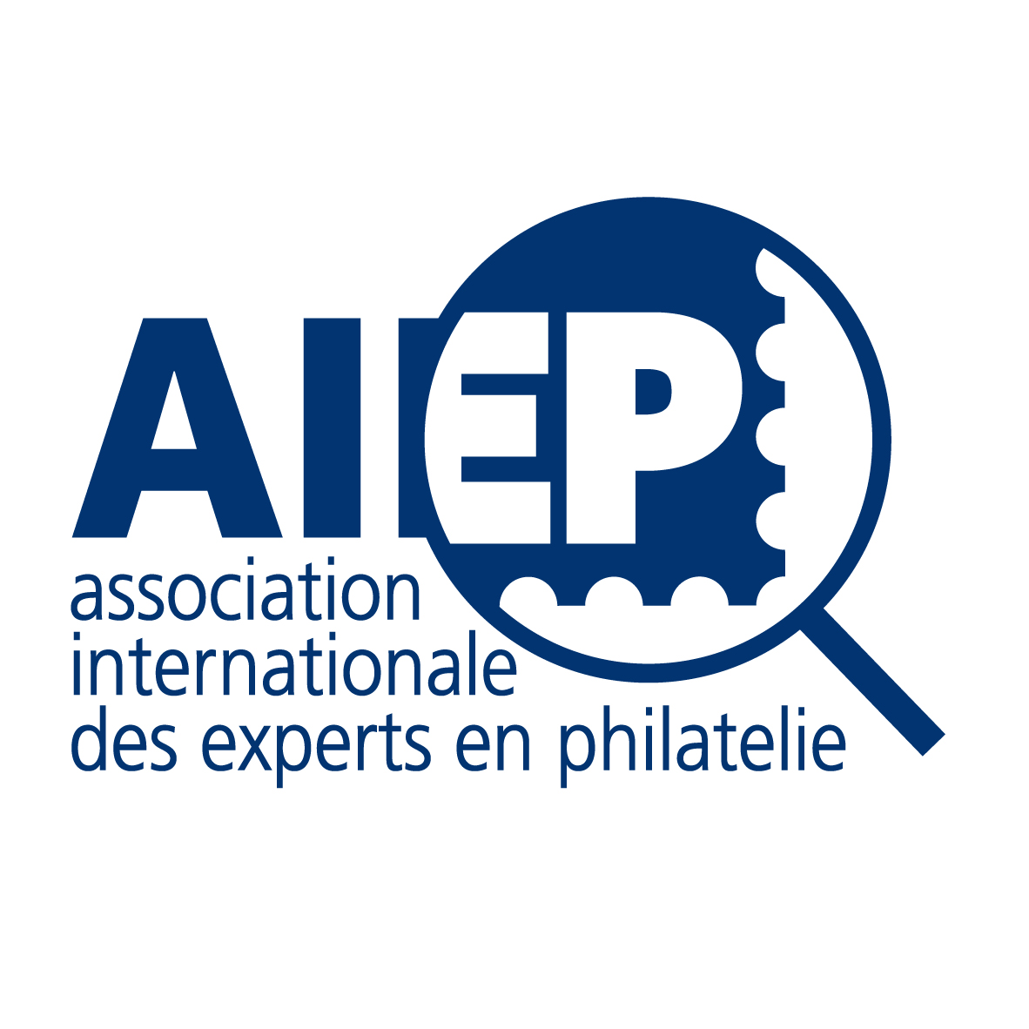
HUNZIKER MEDAL 2018

Dr. Helena Obermüller Wilén

Helena Obermüller Wilén is a silent, but important star of Swedish Philately. She was born into a philatelic family, she took over expertizing after the death of her father Franz Obermüller, her brother ruled the family stamp business Kihlströms Frimärkshanden in Stockholm.

Helena is an expert since 1985, for 34 years, and a member of the AIEP since 1996. Her main area is Sweden (stamps & postal history) 1855-1919 for which she is a leading Expert. She was active in the FIP as a delegate to the Fight against Forgeries Commission (being also Secretary and Bureau Member). At a national level she covers the Presidency of the Expert Committee of the Swedish Philatelic Federation. She is also a member of the FIP Expert Team. But she was also active as an author and wrote several articles about fakes and forgeries in Swedish philatelic periodicals and the FFE Magazine. Issuing since a long time a large number of certificates of Swedish stamps and covers made Helena to a reference person in the Swedish philatelic world.

The Hunziker Medal, named in memory of our past president Hans Hunziker, is awarded by the AIEP for significant literary contribution, or research work concerned with forgeries or philatelic expertizing, or four outstanding expertizing activities. This most important worldwide award for philatelic expertizing was achieved since 1996 to many outstanding experts.

Helena Obermüller Wilén’s work covers in an impressive manner the expertizing criteria of the Hunziker Medal. Therefore the Panel decided unanimously that the 2018 Hunziker Medal shall be give in the hands of Dr. Helena Obermüller-Wilén of Huddinge, Sweden.

The Judging Panel

Dr. Thomas Mathà – Mag. Klaus Schöpfer – Carl A. Møller

Stockholm May 30, 2019

Please see picture on next page

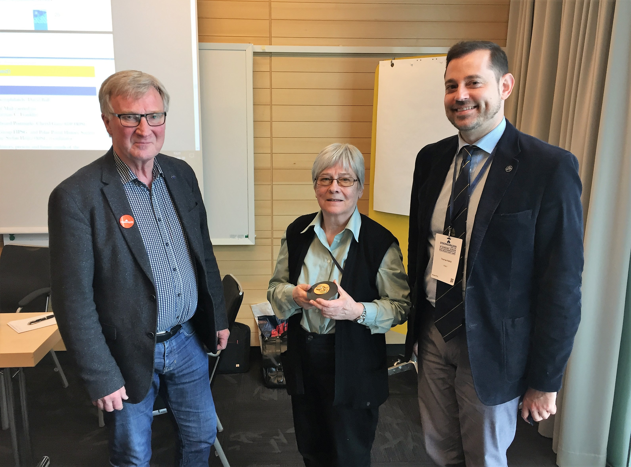

Carl Aage Møller , Helena Obermüller Wilén. Thomas Mathà

